Oblique Circular Conical Surface
# Source: AI Source: Provided by: [Data Path: Persons Table -> ID Column: 1, Name_En Column: Motasem Essam] -> From: [ChatGPT] on [7/20/2026]
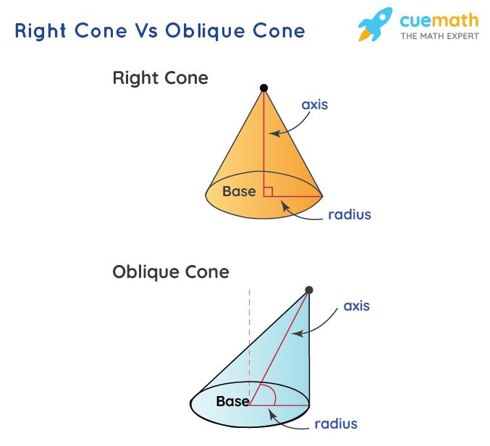
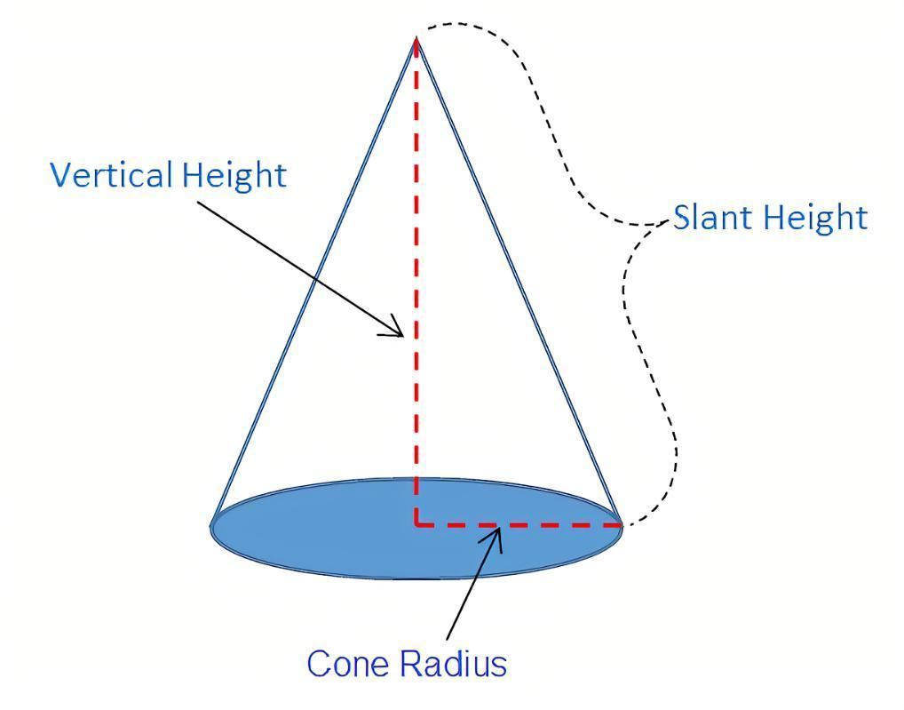
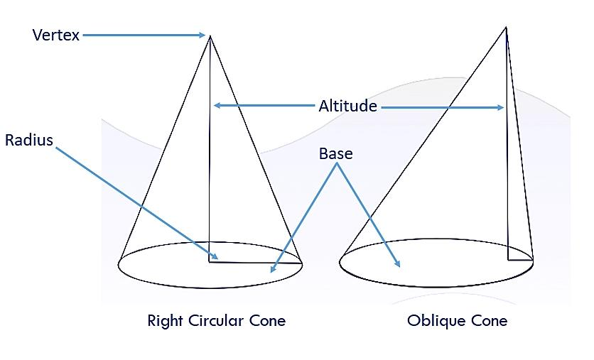
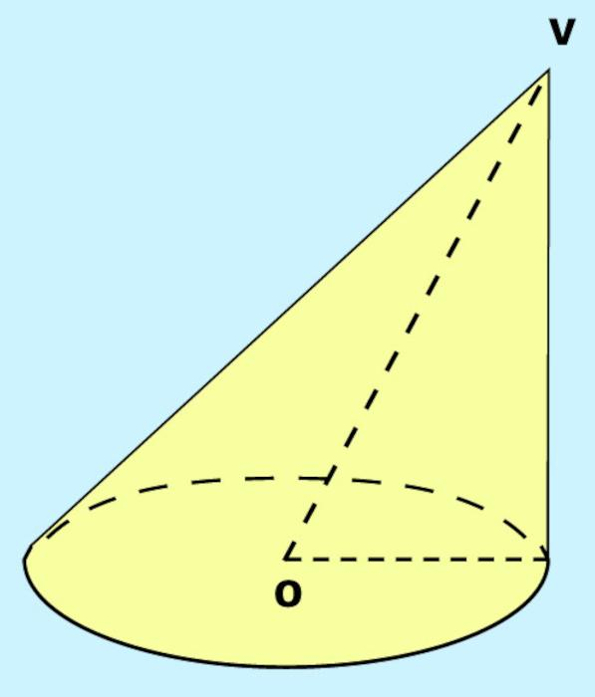
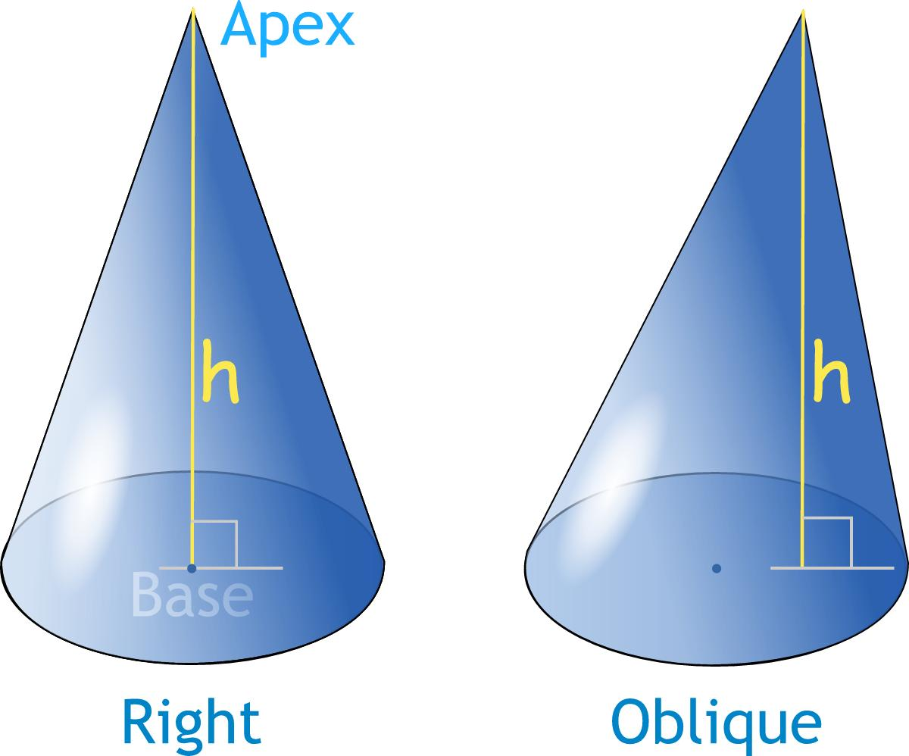

Definition
# Source: AI Source: Provided by: [Data Path: Persons Table -> ID Column: 1, Name_En Column: Motasem Essam] -> From: [ChatGPT] on [7/20/2026]
An Oblique Circular Conical Surface is a conical surface generated by a straight line called a generator that passes through a fixed point called the vertex and moves around a circular directrix, where the axis is not perpendicular to the plane of the circular directrix.
In other words, it is the curved lateral surface of an oblique circular cone.
Unlike a Right Circular Conical Surface, the vertex is not directly above or below the center of the circular base.
Main characteristics
- The directrix is a circle.
- All generators pass through the same vertex.
- The axis passes through the vertex and the center of the circular base.
- The axis is not perpendicular to the base plane.
- The cone is generally asymmetric around its axis.
- The generators generally have different lengths.

Purpose
# Source: AI Source: Provided by: [Data Path: Persons Table -> ID Column: 1, Name_En Column: Motasem Essam] -> From: [ChatGPT] on [7/20/2026]
An oblique circular conical surface is useful for:
- Studying non-right conical geometry.
- Modeling inclined or tilted conical structures.
- Understanding the difference between right and oblique cones.
- Describing conical surfaces in three-dimensional geometry.
- Modeling engineering and architectural structures.
- Studying volume and cross-sections of oblique solids.

Fundamental Elements
# Source: AI Source: Provided by: [Data Path: Persons Table -> ID Column: 1, Name_En Column: Motasem Essam] -> From: [ChatGPT] on [7/20/2026]
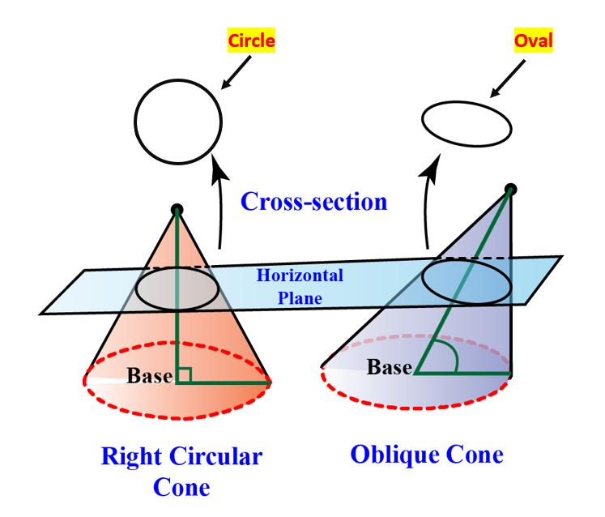
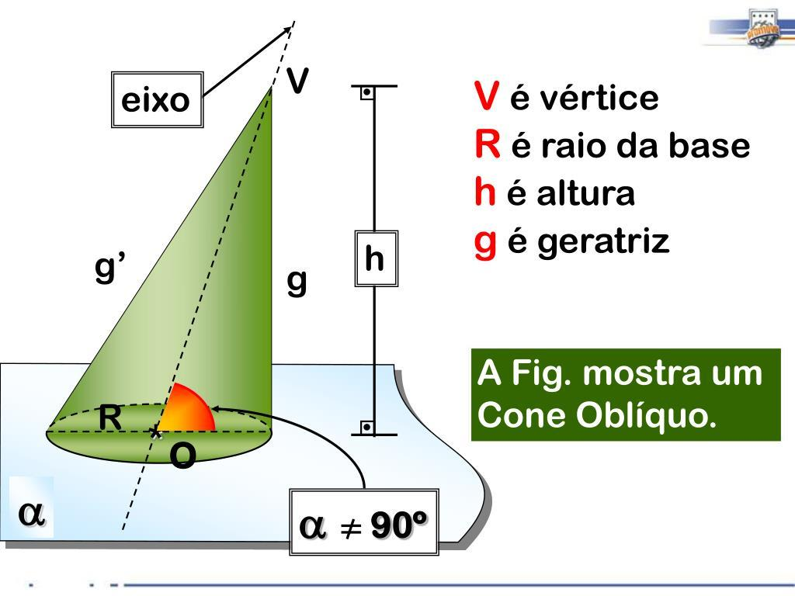
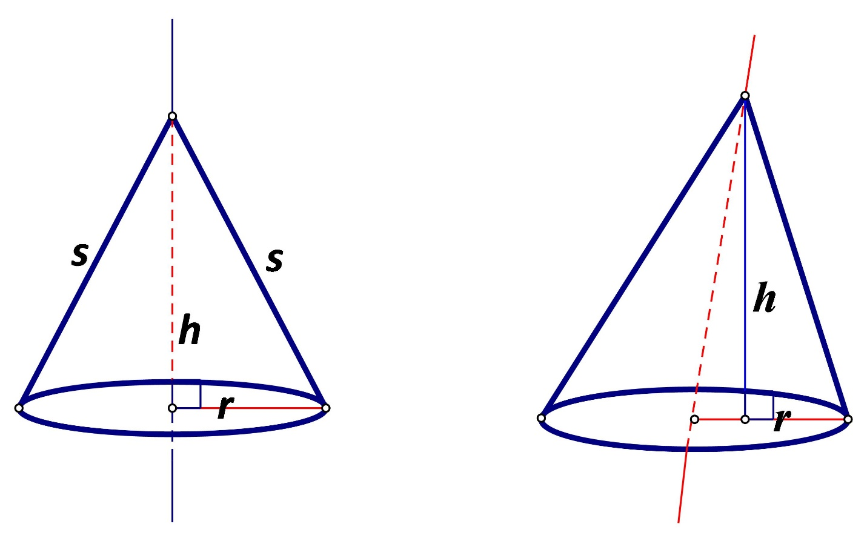

1. Vertex
# Source: AI Source: Provided by: [Data Path: Persons Table -> ID Column: 1, Name_En Column: Motasem Essam] -> From: [ChatGPT] on [7/20/2026]
The vertex $V$is the fixed point through which all generators pass.

2. Circular Directrix
# Source: AI Source: Provided by: [Data Path: Persons Table -> ID Column: 1, Name_En Column: Motasem Essam] -> From: [ChatGPT] on [7/20/2026]
The directrix is the circular curve forming the base boundary.
Its radius is
$$r.$$

3. Center of the Directrix
# Source: AI Source: Provided by: [Data Path: Persons Table -> ID Column: 1, Name_En Column: Motasem Essam] -> From: [ChatGPT] on [7/20/2026]
Let $O$be the center of the circular directrix.
The line $VO$is commonly called the axis of the cone.

4. Axis
# Source: AI Source: Provided by: [Data Path: Persons Table -> ID Column: 1, Name_En Column: Motasem Essam] -> From: [ChatGPT] on [7/20/2026]
For an oblique circular cone, the axis is not perpendicular to the base plane.
Thus,
$$\boxed{VO⊥̸\text{base plane}}$$
This is the defining geometric distinction from a right circular cone.

5. Perpendicular Height
# Source: AI Source: Provided by: [Data Path: Persons Table -> ID Column: 1, Name_En Column: Motasem Essam] -> From: [ChatGPT] on [7/20/2026]
The height $h$is the perpendicular distance from the vertex to the plane containing the circular directrix.
Importantly, the height is not generally the same as the axis length $VO$.
If $θ$is the angle between the axis and the perpendicular direction to the base plane, then
$$\boxed{h=VO\cos{θ}}.$$

6. Generators
# Source: AI Source: Provided by: [Data Path: Persons Table -> ID Column: 1, Name_En Column: Motasem Essam] -> From: [ChatGPT] on [7/20/2026]
A generator is a straight line from the vertex to a point on the circular directrix.
Unlike the right circular cone, the generators generally do not all have the same length.

Mathematical Representation
# Source: AI Source: Provided by: [Data Path: Persons Table -> ID Column: 1, Name_En Column: Motasem Essam] -> From: [ChatGPT] on [7/20/2026]
Consider a circular directrix of radius $r$lying in the plane
$$z=0$$
with center
$$O=\left(0 , 0 , 0\right).$$
Let the vertex be
$$V=\left(a , b , h\right).$$
If
$$\left(a , b\right)≠\left(0 , 0\right),$$
the vertex is horizontally displaced from the point directly above the center.
The perpendicular height is still
$$\boxed{h}.$$
A parametric representation of the circular directrix is
$$c\left(θ\right)=\left(r , \cos{θ} , r\sin{θ} 0\right).$$
The oblique conical surface can then be represented by
$$\boxed{R\left(t , θ\right)=\left(1-t\right)V+tc\left(θ\right)}$$
where
$$0≤t≤1, 0≤θ<2π.$$
Substituting $V=\left(a , b , h\right)$,
$$\boxed{R\left(t , θ\right)=\left(\left(1-t\right) , a , +tr\cos{θ} \left(1-t\right)b+tr\sin{θ} \left(1-t\right)h\right)}.$$
This describes the entire finite lateral surface.

Height and Axis Length
# Source: AI Source: Provided by: [Data Path: Persons Table -> ID Column: 1, Name_En Column: Motasem Essam] -> From: [ChatGPT] on [7/20/2026]
For an oblique circular cone, distinguish carefully between:
- Perpendicular height $h$
- Axis length $d=VO$
If
$$V=\left(a , b , h\right),$$
then
$$VO=\sqrt{a^{2}+b^{2}+h^{2}}.$$
Therefore,
$$\boxed{VO=\sqrt{d^{2}+h^{2}}}$$
where
$$d=\sqrt{a^{2}+b^{2}}$$
is the horizontal displacement of the vertex from the center's perpendicular projection.
Thus,
$$\boxed{VO^{2}=h^{2}+d^{2}}.$$

Generator Length
# Source: AI Source: Provided by: [Data Path: Persons Table -> ID Column: 1, Name_En Column: Motasem Essam] -> From: [ChatGPT] on [7/20/2026]
Consider a point on the circular directrix:
$$P=\left(r , \cos{θ} , r\sin{θ}0\right).$$
The generator from $V=\left(a , b , h\right)$to $P$has length
$$VP=\sqrt{{\left(r\cos{θ}-a\right)}^{2}+{\left(r\sin{θ}-b\right)}^{2}+h^{2}}.$$
Therefore,
$$\boxed{VP=\sqrt{r^{2}+a^{2}+b^{2}+h^{2}-2r\left(a\cos{θ}+b\sin{θ}\right)}}.$$
Unlike the right circular cone, this length generally depends on $θ$.
Therefore:
$$\boxed{\text{Generators are generally not equal in length.}}$$

Surface Area
# Source: AI Source: Provided by: [Data Path: Persons Table -> ID Column: 1, Name_En Column: Motasem Essam] -> From: [ChatGPT] on [7/20/2026]
This is an important distinction from the right circular cone.
For a right circular cone,
$$A=πrl.$$
For an oblique circular cone, there is generally no single slant height $l$that can be used in the same elementary formula.
Therefore, one should not automatically use
$$πrl$$
for an oblique circular conical surface.
The exact lateral surface area depends on the geometry of the oblique cone.
For a parametric surface
$$R\left(t , θ\right),$$
the surface area is calculated using
$$\boxed{A=\int_{0}^{2π}{\int_{0}^{1}{∣\frac{∂R}{∂t}×\frac{∂R}{∂θ}∣}} dt dθ}.$$
This is the general calculus-based treatment.

Volume of the Corresponding Oblique Cone
# Source: AI Source: Provided by: [Data Path: Persons Table -> ID Column: 1, Name_En Column: Motasem Essam] -> From: [ChatGPT] on [7/20/2026]
Although the lateral surface area becomes more complicated, the volume of the corresponding oblique circular cone has the same basic formula as a right circular cone:
$$\boxed{V=\frac{1}{3}πr^{2}h}$$
where $h$is the perpendicular height.
This is an important result:
The volume depends on the base area and perpendicular height, not on whether the cone is right or oblique.

Example 1 – Identifying an Oblique Cone
# Source: AI Source: Provided by: [Data Path: Persons Table -> ID Column: 1, Name_En Column: Motasem Essam] -> From: [ChatGPT] on [7/20/2026]
Suppose a cone has:
- Circular base.
- Vertex above the base plane but displaced from the base center.
- Axis not perpendicular to the base.
Then the surface is an:
$$\boxed{\text{Oblique Circular Conical Surface}}$$
because:
$$\text{Circular directrix}+\text{non-perpendicular axis}$$
gives an oblique circular conical surface.

Example 2 – Finding the Axis Length
# Source: AI Source: Provided by: [Data Path: Persons Table -> ID Column: 1, Name_En Column: Motasem Essam] -> From: [ChatGPT] on [7/20/2026]
Suppose:
$$h=12\text{ cm}$$
and the horizontal displacement between the vertex projection and the base center is
$$d=5\text{ cm}.$$
Then
$$VO=\sqrt{h^{2}+d^{2}}.$$
Therefore,
$$VO=\sqrt{{12}^{2}+5^{2}} \\ VO=\sqrt{144+25} \\ VO=\sqrt{169} \\ \boxed{VO=13\text{ cm}}.$$
Notice that:
$$VO≠h.$$
The perpendicular height is $12$cm, while the axis length is $13$cm.

Example 3 – Volume
# Source: AI Source: Provided by: [Data Path: Persons Table -> ID Column: 1, Name_En Column: Motasem Essam] -> From: [ChatGPT] on [7/20/2026]
Suppose the circular base has radius
$$r=4\text{ cm}$$
and the perpendicular height is
$$h=9\text{ cm}.$$
Then
$$V=\frac{1}{3}πr^{2}h.$$
Thus,
$$V=\frac{1}{3}π\left(4^{2}\right)\left(9\right) \\ V=\frac{1}{3}π\left(16\right)\left(9\right) \\ \boxed{V=48π{\text{ cm}}^{3}}.$$
Approximately,
$$\boxed{V≈150.80{\text{ cm}}^{3}}.$$

Main Properties
# Source: AI Source: Provided by: [Data Path: Persons Table -> ID Column: 1, Name_En Column: Motasem Essam] -> From: [ChatGPT] on [7/20/2026]
An oblique circular conical surface has the following properties:
- Its directrix is a circle.
- All generators pass through one common vertex.
- The generators are not generally perpendicular to the base.
- The axis is not perpendicular to the base plane.
- The vertex is displaced from the point directly above the base center.
- The surface is curved.
- The surface has one vertex.
- The generators generally have different lengths.
- The lateral surface alone is an open surface.
- Adding the circular base produces a closed surface.
- The surface generally does not have rotational symmetry about its axis.
- Its corresponding solid has volume
$$\boxed{V=\frac{1}{3}πr^{2}h}.$$

Right Circular vs Oblique Circular Conical Surface
# Source: AI Source: Provided by: [Data Path: Persons Table -> ID Column: 1, Name_En Column: Motasem Essam] -> From: [ChatGPT] on [7/20/2026]
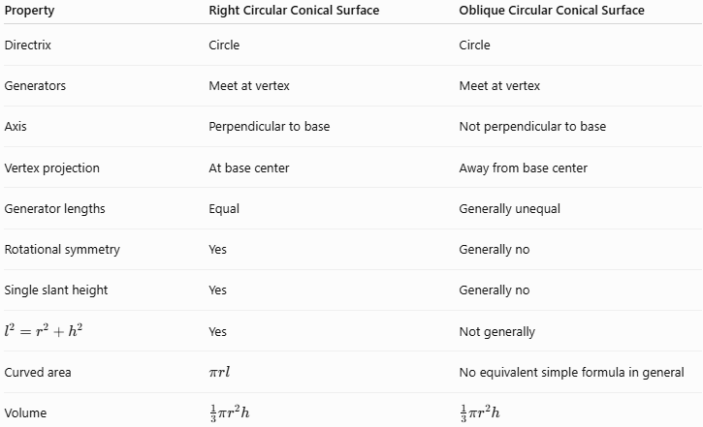
Property | Right Circular Conical Surface | Oblique Circular Conical Surface
Directrix | Circle | Circle
Generators | Meet at vertex | Meet at vertex
Axis | Perpendicular to base | Not perpendicular to base
Vertex projection | At base center | Away from base center
Generator lengths | Equal | Generally unequal
Rotational symmetry | Yes | Generally no
Single slant height | Yes | Generally no
$$l^{2}=r^{2}+h^{2}$$ | Yes | Not generally
Curved area | $$πrl$$ | No equivalent simple formula in general
Volume | $$\frac{1}{3}πr^{2}h$$ | $$\frac{1}{3}πr^{2}h$$

Oblique Circular Conical Surface vs Oblique Circular Cylindrical Surface
# Source: AI Source: Provided by: [Data Path: Persons Table -> ID Column: 1, Name_En Column: Motasem Essam] -> From: [ChatGPT] on [7/20/2026]
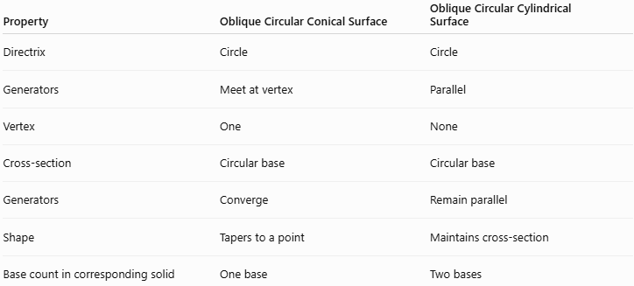
Property | Oblique Circular Conical Surface | Oblique Circular Cylindrical Surface
Directrix | Circle | Circle
Generators | Meet at vertex | Parallel
Vertex | One | None
Cross-section | Circular base | Circular base
Generators | Converge | Remain parallel
Shape | Tapers to a point | Maintains cross-section
Base count in corresponding solid | One base | Two bases
The essential difference remains:
$$\boxed{\text{Cone: generators meet at one vertex}} \\ \boxed{\text{Cylinder: generators remain parallel}}$$

Relationship with Right Circular Conical Surface
# Source: AI Source: Provided by: [Data Path: Persons Table -> ID Column: 1, Name_En Column: Motasem Essam] -> From: [ChatGPT] on [7/20/2026]
Both are subclasses of Circular Conical Surface.
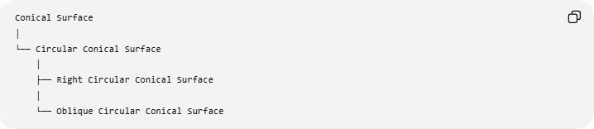
Conical Surface
│
└── Circular Conical Surface
│
├── Right Circular Conical Surface
│
└── Oblique Circular Conical Surface
The classification is based on the orientation of the axis:
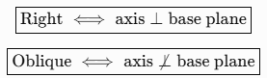
$$\boxed{\text{Right }⟺\text{ axis}⊥\text{base plane}} \\ \boxed{\text{Oblique }⟺\text{ axis}⊥̸\text{base plane}}$$

Relationship with General Conical Surface
# Source: AI Source: Provided by: [Data Path: Persons Table -> ID Column: 1, Name_En Column: Motasem Essam] -> From: [ChatGPT] on [7/20/2026]
The broader classification can be represented as:
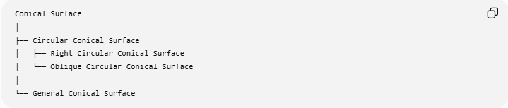
Conical Surface
│
├── Circular Conical Surface
│ ├── Right Circular Conical Surface
│ └── Oblique Circular Conical Surface
│
└── General Conical Surface
Here, circular describes the shape of the directrix, while right/oblique describes the orientation.
This distinction is important for keeping your knowledge-base taxonomy precise.

Real-World Applications
# Source: AI Source: Provided by: [Data Path: Persons Table -> ID Column: 1, Name_En Column: Motasem Essam] -> From: [ChatGPT] on [7/20/2026]
Oblique circular conical surfaces can occur in:
- Inclined funnels
- Tilted hoppers
- Engineering components
- Architectural structures
- Sloping roofs
- Industrial containers
- Fluid-flow equipment
- Specialized nozzles
- Mechanical components
- 3D computer modeling

Advantages
# Source: AI Source: Provided by: [Data Path: Persons Table -> ID Column: 1, Name_En Column: Motasem Essam] -> From: [ChatGPT] on [7/20/2026]
- Generalizes the familiar right circular cone.
- Can model inclined conical structures.
- Retains a circular base.
- Volume calculation remains simple.
- Useful in three-dimensional geometry and engineering.
- Provides a useful example of symmetry being lost through inclination.

Limitations
# Source: AI Source: Provided by: [Data Path: Persons Table -> ID Column: 1, Name_En Column: Motasem Essam] -> From: [ChatGPT] on [7/20/2026]
- Generally lacks rotational symmetry.
- Generator lengths are not generally equal.
- There is no single slant height for the entire surface.
- The simple formula
$$A=πrl$$
cannot generally be used for lateral surface area.
- Surface-area calculations can require calculus or more advanced geometry.

Key Points
# Source: AI Source: Provided by: [Data Path: Persons Table -> ID Column: 1, Name_En Column: Motasem Essam] -> From: [ChatGPT] on [7/20/2026]
- An Oblique Circular Conical Surface has a circular directrix.
- Its generators all pass through one vertex.
- Its axis is not perpendicular to the base plane.
- The vertex is not directly above the center of the circular base.
- Its perpendicular height $h$differs from the axis length $VO$.
- Generator lengths are generally unequal.
- There is generally no single slant height.
- The right-cone formula
$$A=πrl$$
should not be automatically applied.
- The corresponding solid still has volume
$$\boxed{V=\frac{1}{3}πr^{2}h}.$$
- It is a special type of Circular Conical Surface.

